Control Engineering II

Handout – Online Laboratory 1

Name: *Colda Andreea Ariana*

Group: *30332*

For the process transfer function:

$$H(s)=\frac{15}{s(s+5)}$$

with , solve the following problems:

a) Represent the closed loop responses to a step input, for the continuous time closed loop system,

b) Compute the discrete transfer function for the process using analytical tools and both the zero-order hold and Tustin method, for a sampling period  sec,

*Add photo of analytical discretization (from your notebook), both zoh and Tustin.*

**

**

**

**

c) Check your results using Matlab’s ‘c2d’ function,

d) Compute using Matlab’s ‘c2d’ function the discrete forms of H(s) for  sec and  sec,

e) Compute using Matlab the discrete time closed loop system according to  sec,  sec and  sec,

f) Plot the step responses of the discrete time closed loop system with the three different sampling periods and the step response obtained at a) on the same figure. Compare your results and conclude upon the choice for the sampling period.

*Add plot here*

*Brief comparison and motivate upon the choice of sampling period*

For ZOH method

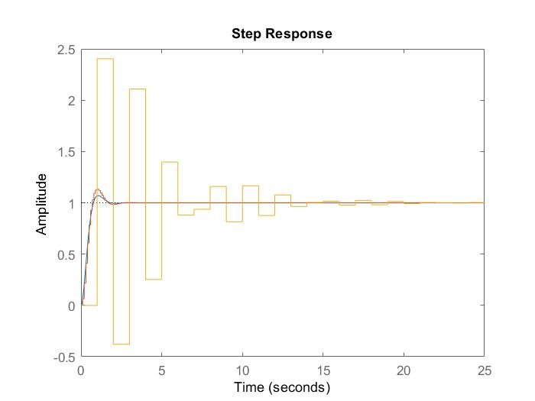

For Tustin’s method

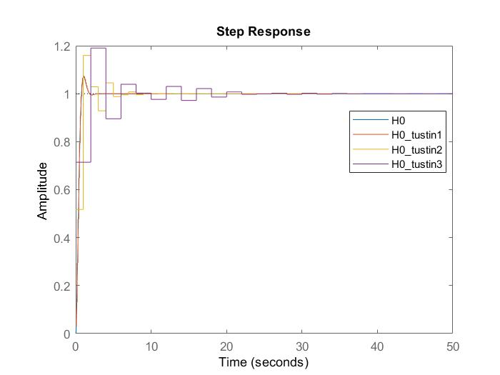

We can see that the Tustin method is more complex and much better than the zero order hold. The zero order hold is much simpler.

We can see that if the sampling period increases the dynamics of the process is wrongly displayed.